Diary 3- 19/10/2020

The premise of this game was to create a more complex game based on noughts and crosses that was based around using different elements of chance with minor bits of skill thrown into the mix. The way this was achieved was by adding into the game pieces, 2 sets of 32 cards the player would have to draw dictated by the dice that they roll each individual turn.

The aim of the game remained the same, in which you must match 3 of your own game pieces in a row or in a diagonal line, however the player may not just place their piece upon the board like a normal would allow. Instead each turn the player must roll a die then draw a card based on what number they rolled (I.E if the player rolls an even number they must draw from the even pile and likewise for the odd numbers.) These cards then allow the player to take actions after drawing the card which for the even cards are optional, but the odd cards are an obligation.

The materials used to create and play this game are:

* 1 noughts and crosses boards
* 5 of each game piece (noughts and crosses)
* 2 different dice (1 for each player)
* 64 different styled cards (32 for odd and 32 for even)

Modifying the mechanics of the game was a must for the success of this projects, relying on the minimalistic skill involved of the game was simply not enough and whilst the element of chance was involved within the dice throw from each player, this was not enough to consider the original game modified. Instead the cards allowed a wider range of chance to be involved as the player has zero control over what the cards would have the player do. Having said that, the cards mix these two elements together as the player does still have some control over the action when drawing from the even pile.

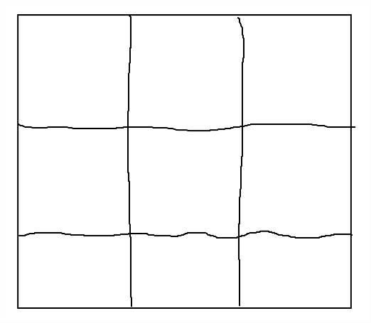

This was the simplistic design for the board of the game. The altering of the board was very difficult as we had to keep the premise of the game as close to the original as possible, therefore the board was something that had to be kept in its original state.

The cards were something that we could have a major brainstorm over, with free range on the possibilities of their affect on and within the game.

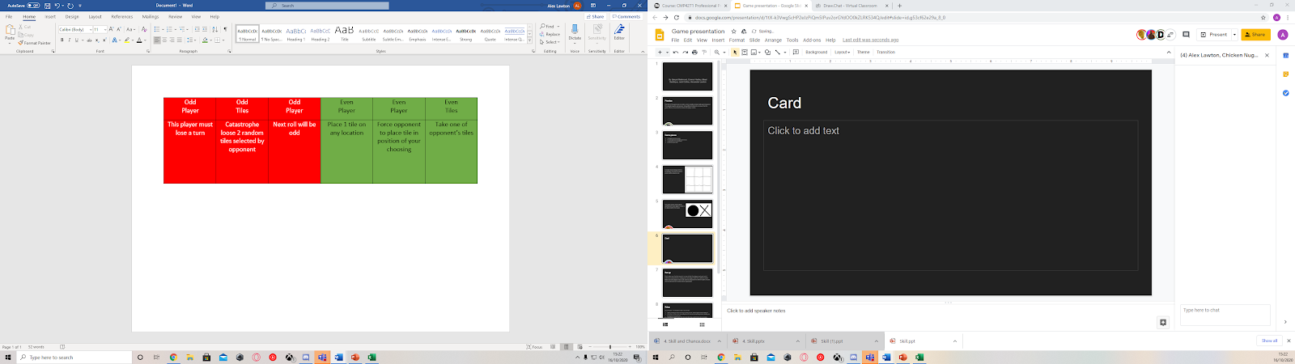

As you can tell from the picture situated to the left, the cards based upon chance however the cards actions allowed the player to call upon their skill and with in order to deal with the effects accordingly.

The design of the cards was a no-brainer as the colour scheme allowed us to show the player straight away whether the card had a positive or negative effect based on the stereotypical colours red and green.



These were the simple game pieces that were placed onto the board upon the cards allowing the player to make their move.

Regarding play testing, originally the game didn’t have the cards operating within the game, relying on just the die to create the element of chance for the player. However, the flaw with this was that the game would often become repetitive and end far too quickly. Another discovery was that the game resembled original noughts and crosses far too much in order to be considered a new game, at which point time was called on the session and the card mechanic was implemented in order to modify the game to a suitable level whilst keeping it enjoyable and exciting.

With regards to the overall discussion, design and play testing of the game, there was several time keeping issues that hindered progress as well as stopped ideas from flowing as well as they could of. However, when on track the communication was superb and the overall effort of the team was exemplary.

The members of the group were: Danyal Mahmood, Connor Hadley, Bilaal Saddique, Jack Collins, Alexander Lawton.